News / Residential Property Developments
ContraVest seeks subcontractors for new
Windermere apts, new land for future

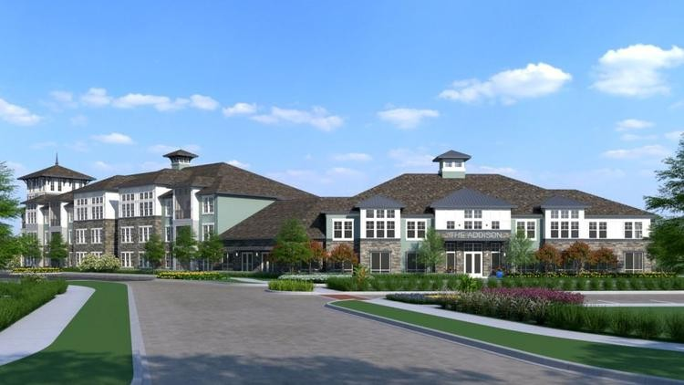

Pictured above is a rendering of the 316-unit Addison at Windermere multi-family development by ContraVest. (CBA Architects)

By Bob Moser • Contact Reporter
GrowthSpotter

MARCH 8, 2016, 1:10 PM | UPDATED: MARCH 8, 2016 6:53 PM

ltamonte Springs-based ContraVest will begin hiring subcontractors and craftsmen of all types for its 316-unit Addison at Windermere apartment community, a $32.6 million
A
investment projected to break ground in July at the intersection of S.R. 535 and Fiquette Road, lead executives with the company said Tuesday.

It's the next bid opportunity for vendors in what should be a busy year for ContraVest, a developer, builder and manager of market rate multi-family communities.

The project will occupy 15 acres of a 21-acre parcel southwest of the intersection, which lies directly south of the Cornerstone at Summerport Publix Shopping Center, and will have partial access through that center's parking lot.

Now under contract, the parcel is currently owned by Clarcona Inc., an affiliate of local real estate owner and developer Lee Chira & Associates.

The Addison at Windermere is fully financed and nearly through its permitting process with Orange County, said Steve Ogier, president of ContraVest Builders and principal with the parent company. Final approval from Orange County Public Schools has delayed the project's construction start from an original target in April.

Roughly 13 miles to the east, ContraVest should break ground this month or April on the 292-unit Addison on Millenia, and is still hiring for a few remaining subcontractor ancillary services, said Gregg Hendershot, vice president of construction.

That multi-family project occupies 11.5 acres of the 87-acre Gardens on Millenia, a retail center being developed jointly by South Florida-based Stiles Corporation and BBX Capital. The property is bordered by Millenia Boulevard and Interstate 4.

BBX Capital and ContraVest Development Partners formed a joint venture in late November to build The Addison on Millenia. That partnership will own the land, build and manage the apartments, with ContraVest as managing member and general contractor.

Seven miles south of the Millenia project is ContraVest's first phase of The Courtney Apartments (355 units), on the northeast corner of Universal Boulevard and Destination Parkway.

The company is under contract to purchase the neighboring 12.16 acres from Orlando Equity Partners for a second phase (345 units) of that project and controls the land, Ogier said. ContraVest is working with OEP to finalize the timing of that sale, but Ogier expects subcontractor bid opportunities to open in the fourth quarter of this year, with a projected start for construction in January 2017.

Those apartments will be surrounded by 20 acres of retail and dining outparcels dubbed Destination Shoppes, being developed ComTerra Development Group and Craft Development Corp. out of Toronto.

ContraVest continues to seek new land acquisition opportunities in the Greater Orlando area. The company favors properties already entitled for multi-family use due to the clear path it provides for financing approval, Ogier said.

Submarkets in Orange and Seminole counties that boast high net worth resident bases will be areas

of focus, or concentrated job markets like the tourism corridor, Medical City and Downtown Orlando, he said.

The company is observing land opportunities in Osceola County with an eye on future growth of technology and manufacturing business segments, but the resident net worth demographics aren't strong enough yet, Ogier said. Similar challenges arise for land in Clermont, where ContraVest is bullish on growth.

Have a tip about Central Florida development? Contact me at bmoser@growthspotter.com, (407)

420-5685 or @bobmoser333. Follow GrowthSpotter on Facebook, Twitter and LinkedIn.

Copyright © 2016, GrowthSpotter

